Student’s Name: Kibet Brian
Admission Number: 190814
Lecturer’s Name: Mr. Talo Harrison
Course Unit: MST 8303 Penetration Testing, PT
Course Code: MST 8303
Lab – Performing a Browser Based Attack
Date: July 13th, 2025

Lab – Performing a Browser Based Attack
Attack Platform: Kali 192.168.100.64
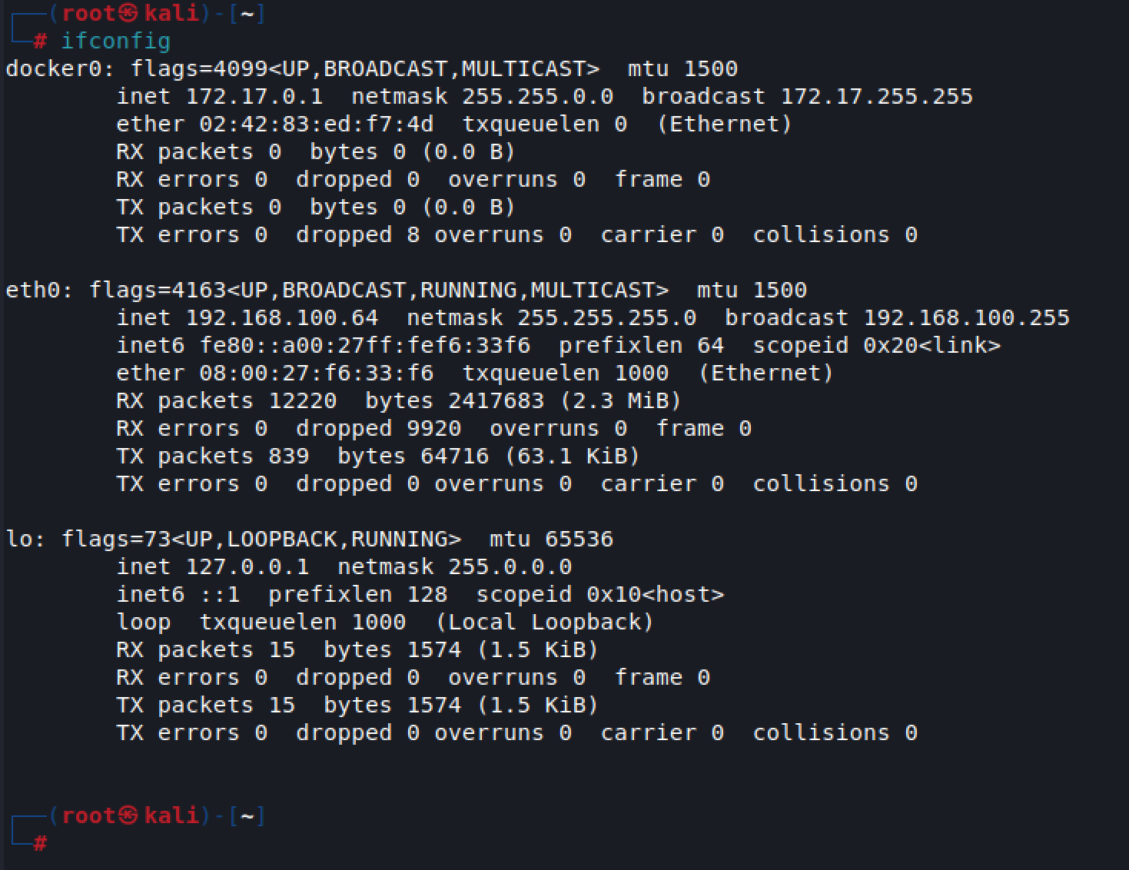

Victim Metasploitable2: 192.168.100.65
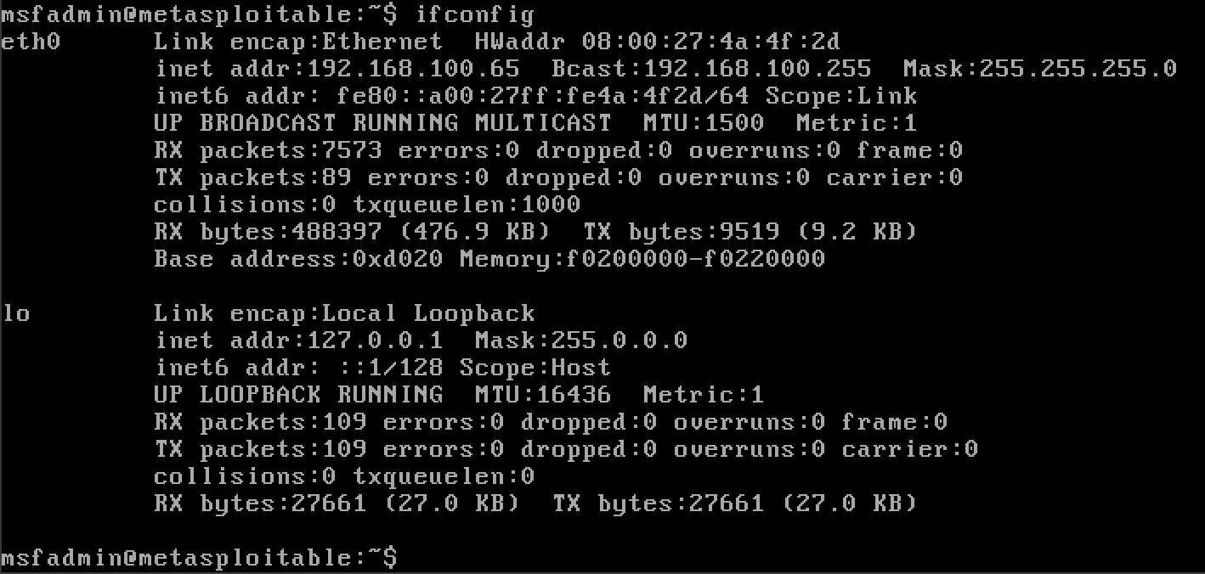

Configuring the mutillidae/config.inc file
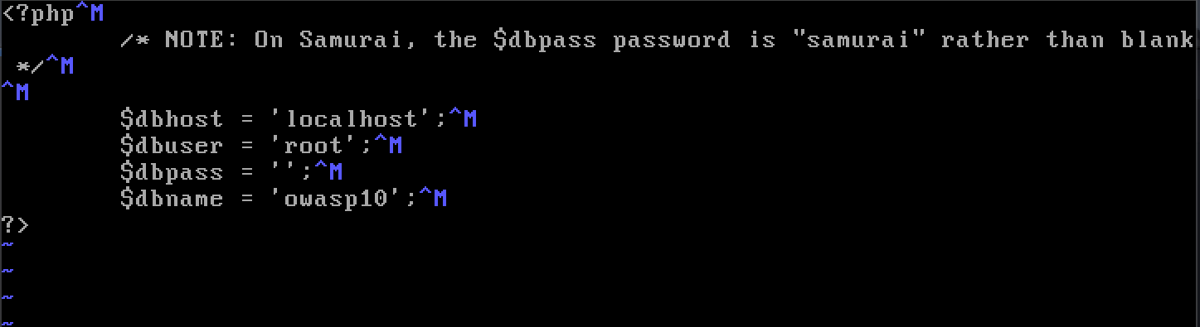

Mutillidae web application on Firefox browser in Kali Linux.
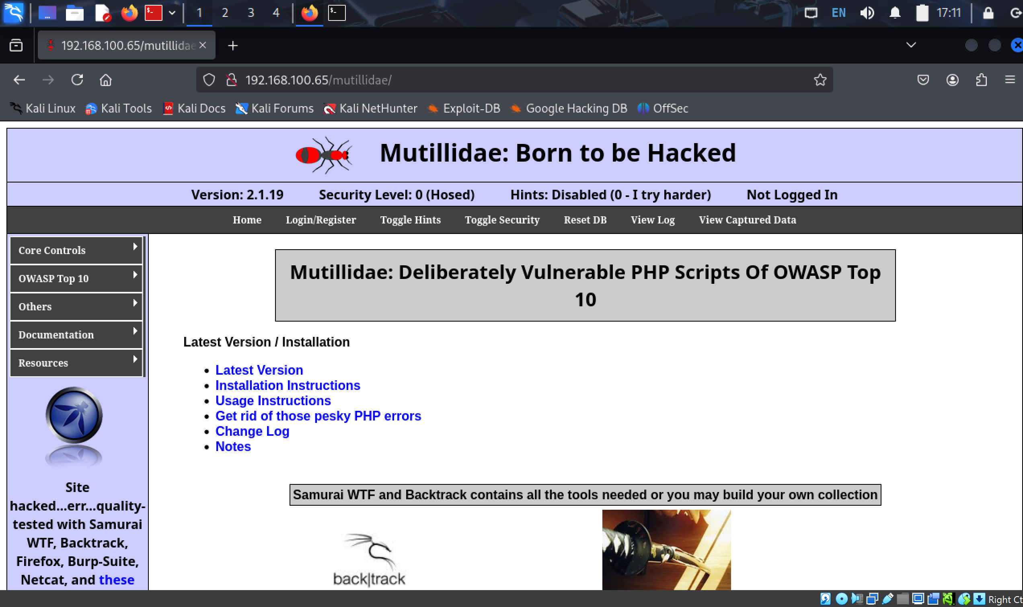
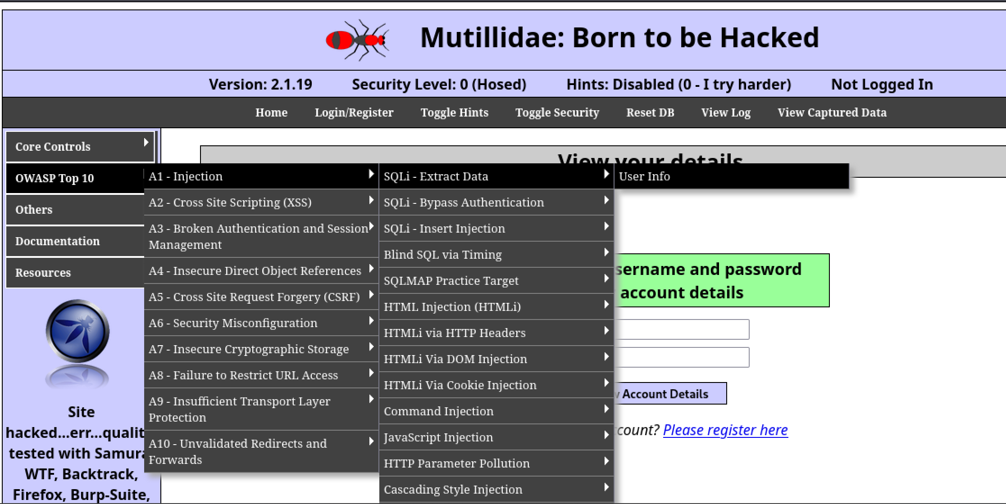
Right clicking Name field and selecting Inspect.
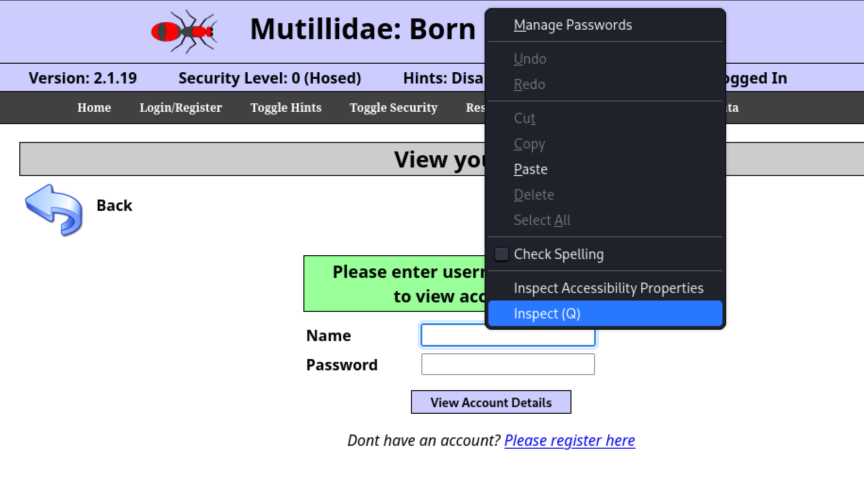
Changing the username size from 20 to 100.
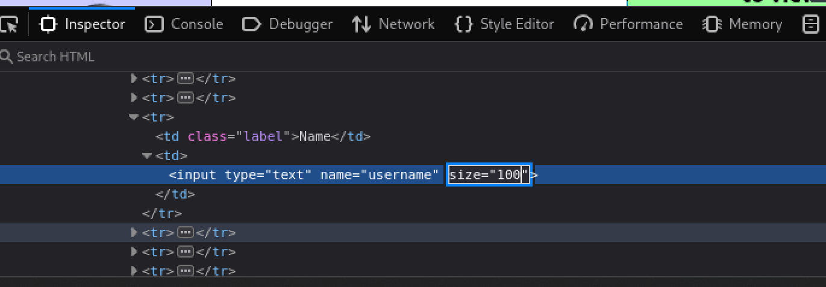

SQL Injection.
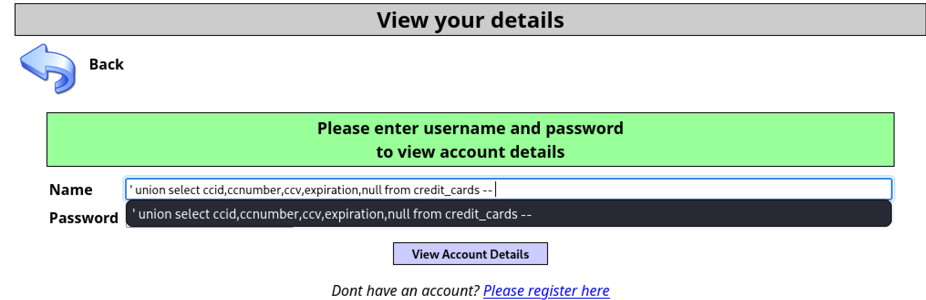

Results from the SQL UNION operator.
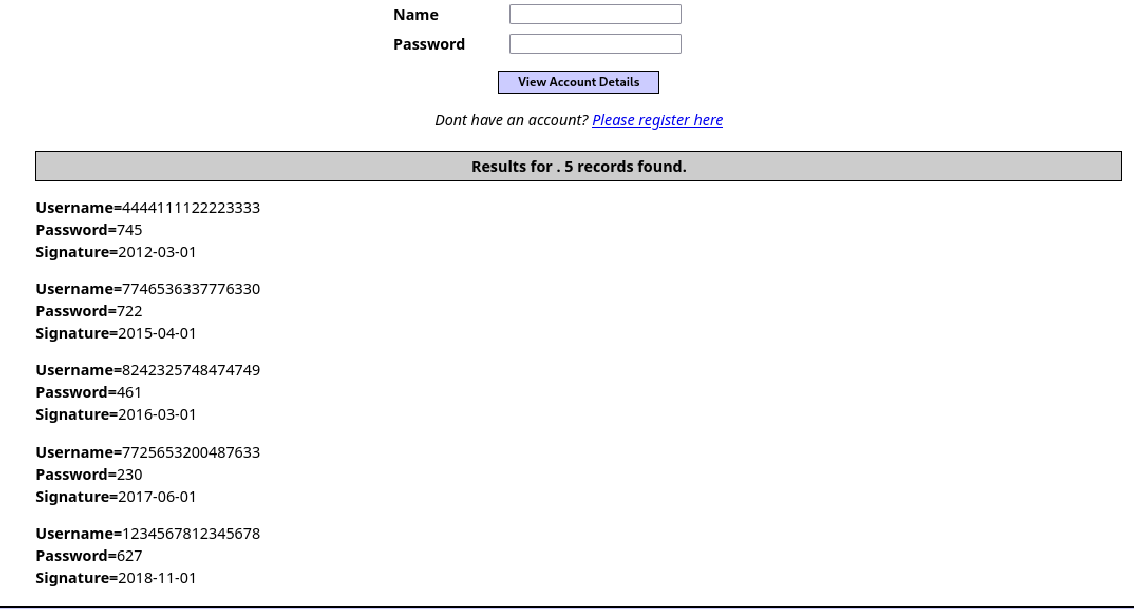

Local File Inclusion and Directory Traversal

Result for: http://192.168.145.128/mutillidae/index.php?page=/etc/passwd
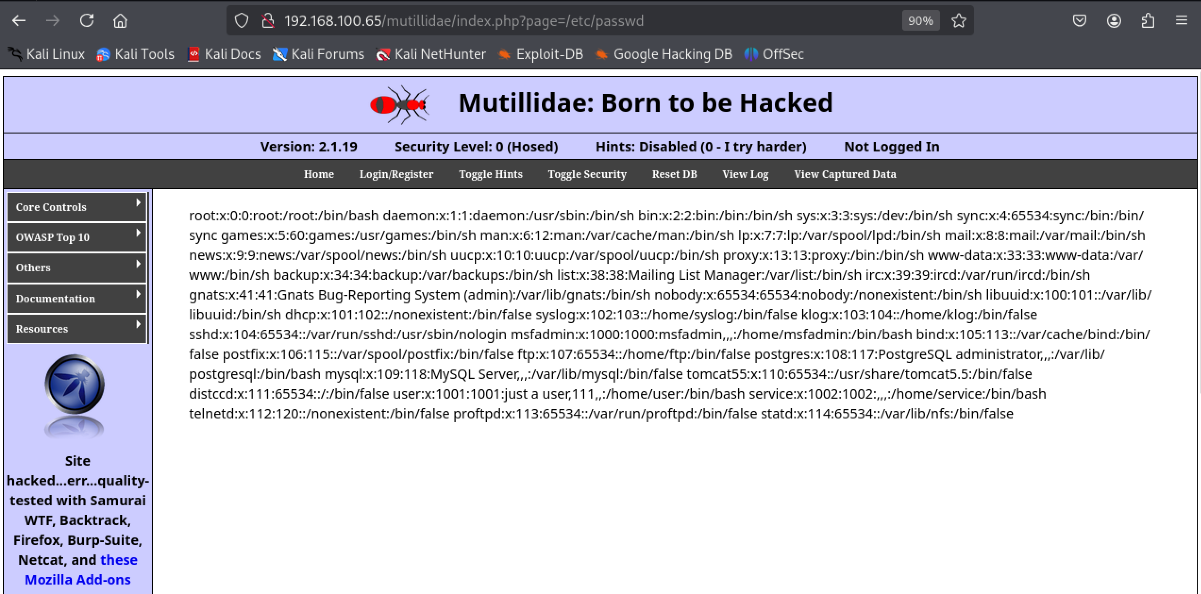

Result for: http://192.168.100.65/mutillidae/index.php?page=/root/.ssh/authorized_keys
